https://leetcode.com/problems/subtract-the-product-and-sum-of-digits-of-an-integer/description/

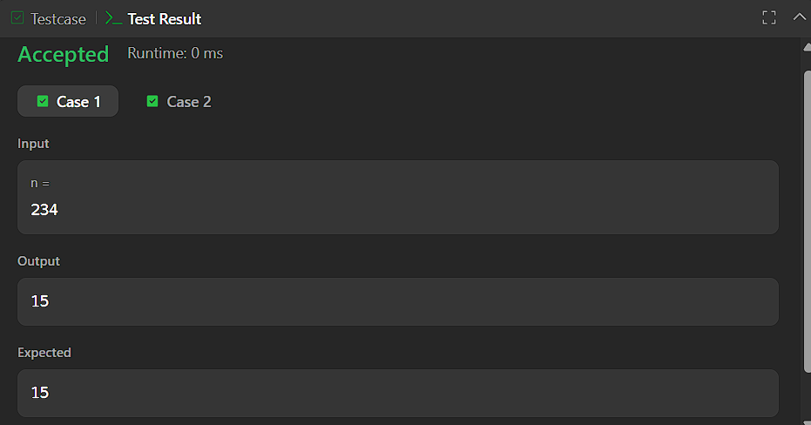


CODE:

int subtractProductAndSum(int n) {
int product = 1;
int sum = 0;

while (n > 0) {
int d = n % 10;
product *= d;
sum += d;
n /= 10;
}

return product - sum;
}

